VISOKA ICT SKOLA

WEB PROGRAMIRANJE PHP1

DOKUMENTACIJA: https://homecinemaproject1337.000webhostapp.com/index.php?page=all

# UVOD

## Koriscenje programskih jezika:

HTML, CSS, JavaScript, jQuery, PHP, MySQL baza

## Opis funkcionalnosti:

Ceo sajt je radjen u Visual Studio Code, sajt je namenjen video klubu i pregledanju filmova na izboru. Sajtu mogu pristupiti neutralizovani i autorizovani korisnici, dok samo autorizovani korisnici mogu videti odredjenje delove.

Na sajtu postoje tri glavna dela: index.php, form.php i movie.php. Uz pomoc superglobalnih promenjivih se moze doci do svake indivitualne stranice. Glavni meni je sastavljen tako da je naslov strane uvek ispisan prvi, a ostali linkovi se menjaju u zavisnosti od toga na kojoj strani se nalazite i da li ste ulogovani ili ne. Sa strane na svakoj stranici se nalazi lista zanrova koji postoje na sajtu i ova lista, kao i linkovi u glavnom meniju su ispisani iz baze podataka.

Na index strani i svim njenim specificnim stranicama se nalazi glavni deo koji sadrzi listu filmova, minimalne informacije o njima i link ka vise specificnoj strani za taj film. Postoji i paginacija i borj filmova na jednoj strani je 16. Na All Movies stranici filmovi si oragizovani po godini zdavanja a na ostalim su po tome kako su dodavani u bazu.

Kada se pritisne na boilo koji film u spisku odlazi se na stranu movie.php tj. stranicu na kojoj se moze videti vise informacija o tom filmu. Kada je korisnik ulogovan vidi se i rezultat ankete tj. broj ljudi koji je glasao za ovaj film.

Stranica form.php obuhvata sve ostale straice sajta i uglavnom vodi ka nekoj strani na kojoj se vrsi obrada informacija iz baze ili upis novih informacija.

Sing up i log in linkovi se vide samo ako korisnik nije ulogovan. Sing up sluzi za prvobitnu registraciju(korisnik se ne moze registrovati kao admin, to pravo moze da samo drugi admin, radi pregledanja sajta jedan od administratorskih naloga je [admin@gmail.com](mailto:admin@gmail.com) i sifra je admin :D) a Log in sluzi za pristup nalogu posle registracije.

Posle aktiviranog i ulogovanog naloga, korisnik na svakoj stranici sajta vidi log out link koji sluzi za odjavljivanje korisnika. Sing up i log in linkovi vise se ne ucitavaju. Isto tako korisniku se pojavljuju dva nova lika survey i „ime korisnika ovde“.

Survey je anketa koju je moguce uraditi samo jednom i sluzi za glasanje za tvoj omiljeni film. Glasovi se mogu videti u svakoj pojedinacoj movie.php stranici.

User strana tj. „ime korisnika ovde“ je link koji izgleda koa korisnicko ime ulogovanog korisnika. Ako je korisnik samo gost na toj strani moze videti neke informacije koje je dao. Ako je korisnik admin moze videti sve naloge i moze ih menjati i brisati po zenji.

U futeru strane postoje tri linka: contact, gallery i link ka ovom dokumentu.

Contact daje izmisljene informacije o video klubu i prave informacije o meni kao autoru.

Gallery sluzi kao galerija i iz baze se ispisuju sve slike za sve filmove koji postoje u bazi.

Mane su sledec:

Kada se korisnik loguje ponekad ne ispisuje link ka users.php tj link sa natpisaom „ime korisnika ovde“.

Kada korisnik glasa za anketu dobijace opciju da opet glasa sve dok se ne izloguje i opet uloguje.

## 1.3 Template

### 1.3.1 index.php

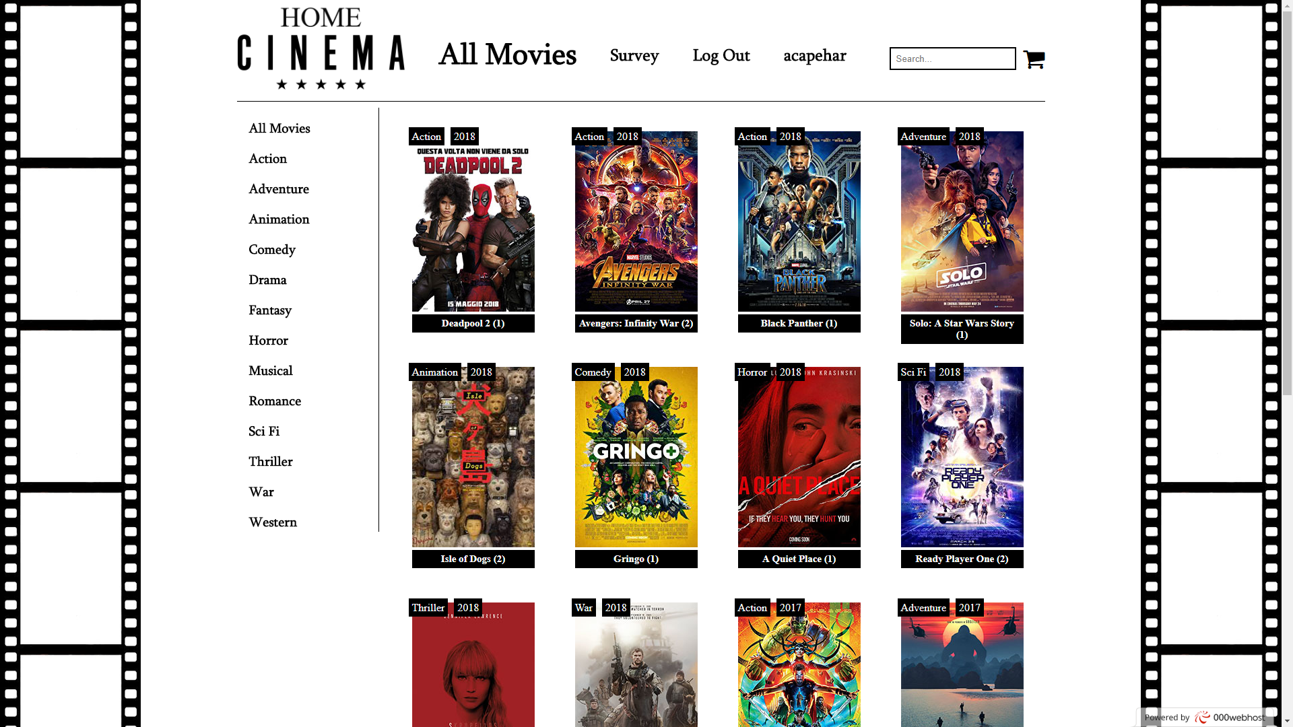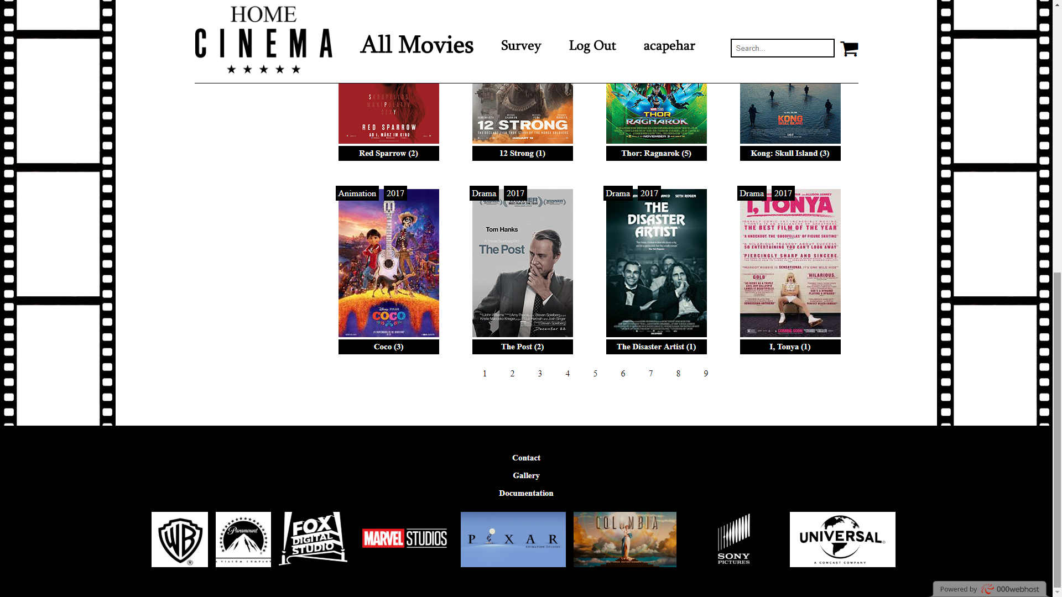

### 1.3.2 movie.php

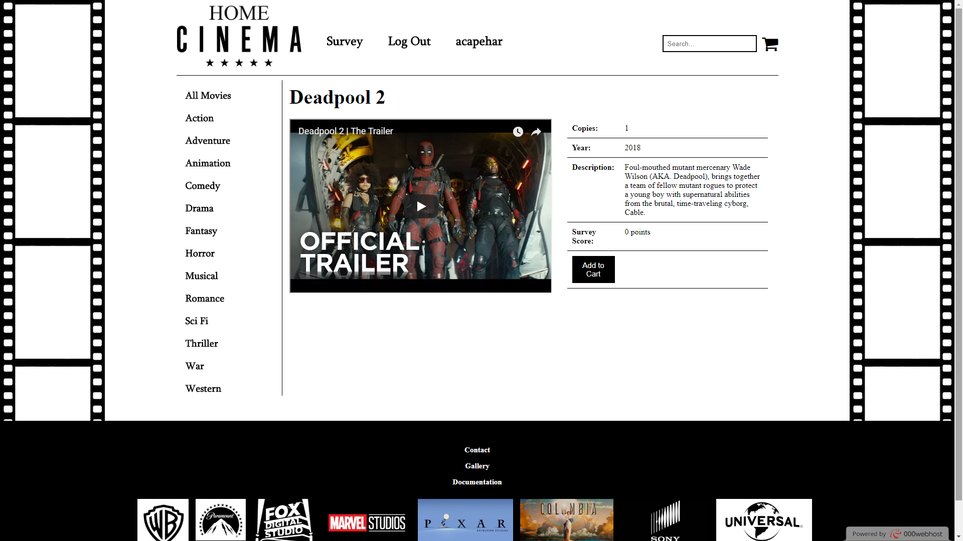

### 1.3.3 form.php?page=singup

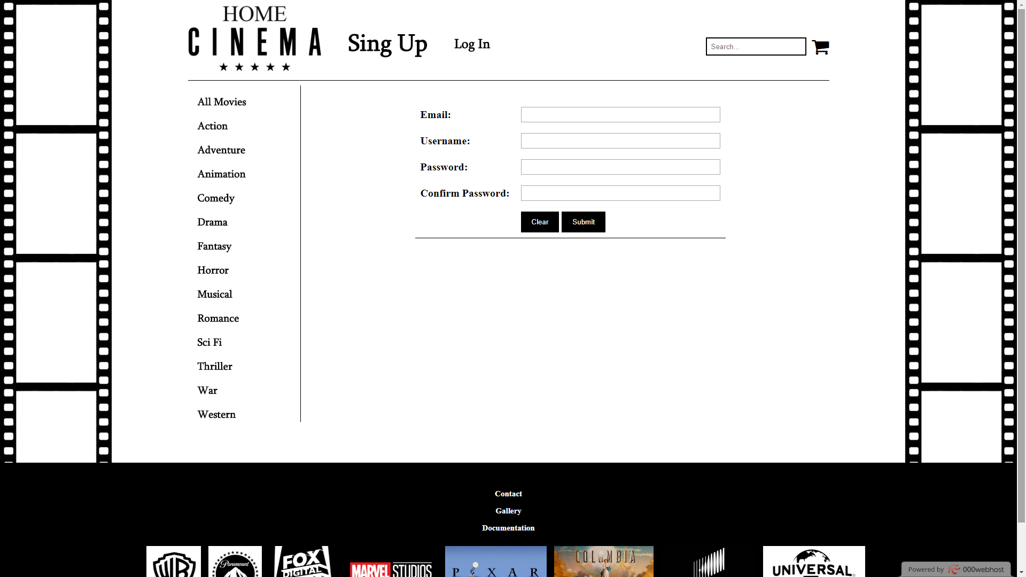

### 1.3.4 form.php?page=login

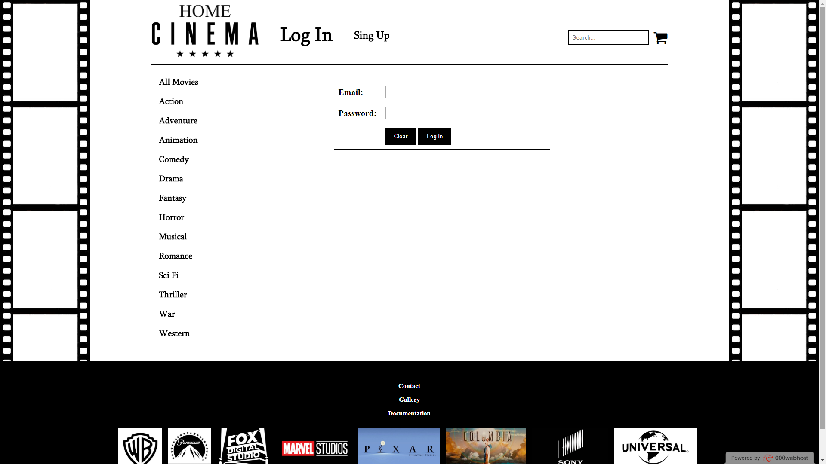

### 1.3.5 form.php?page=form

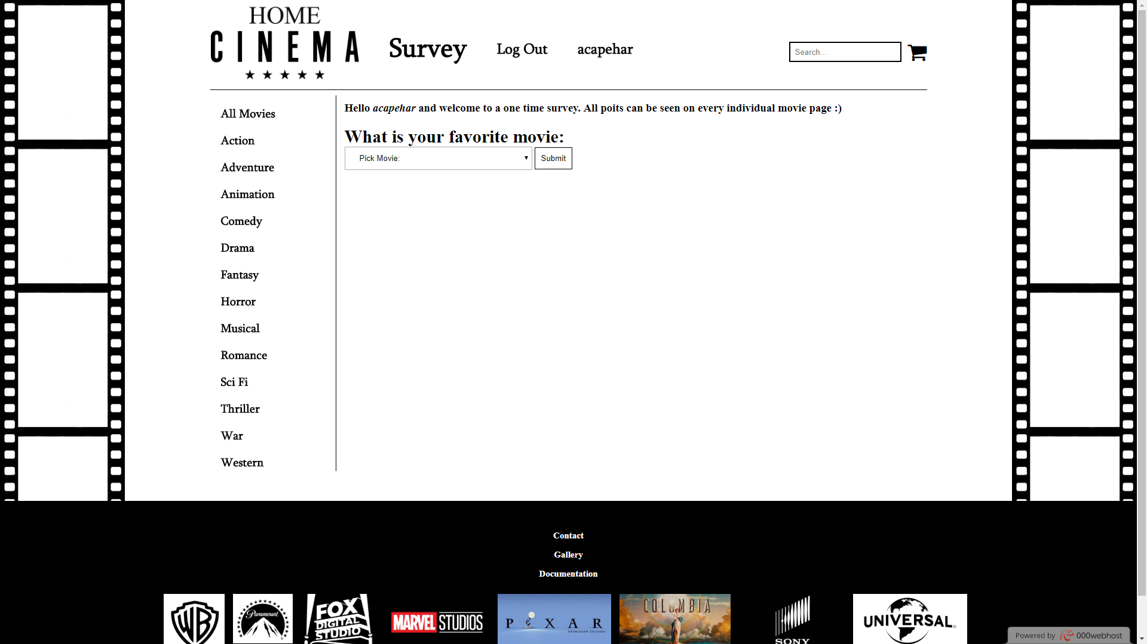

### 1.3.6 form.php?page=user(ADMIN)

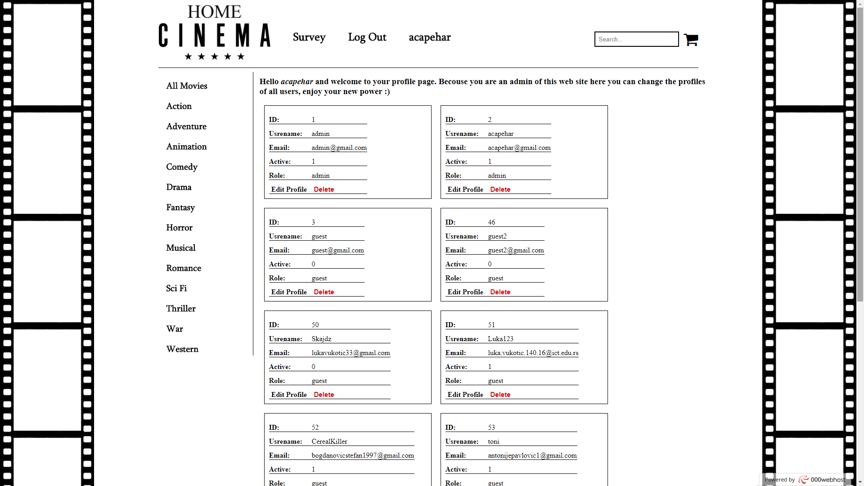

### 1.3.7 form.php?page=user(GUEST)

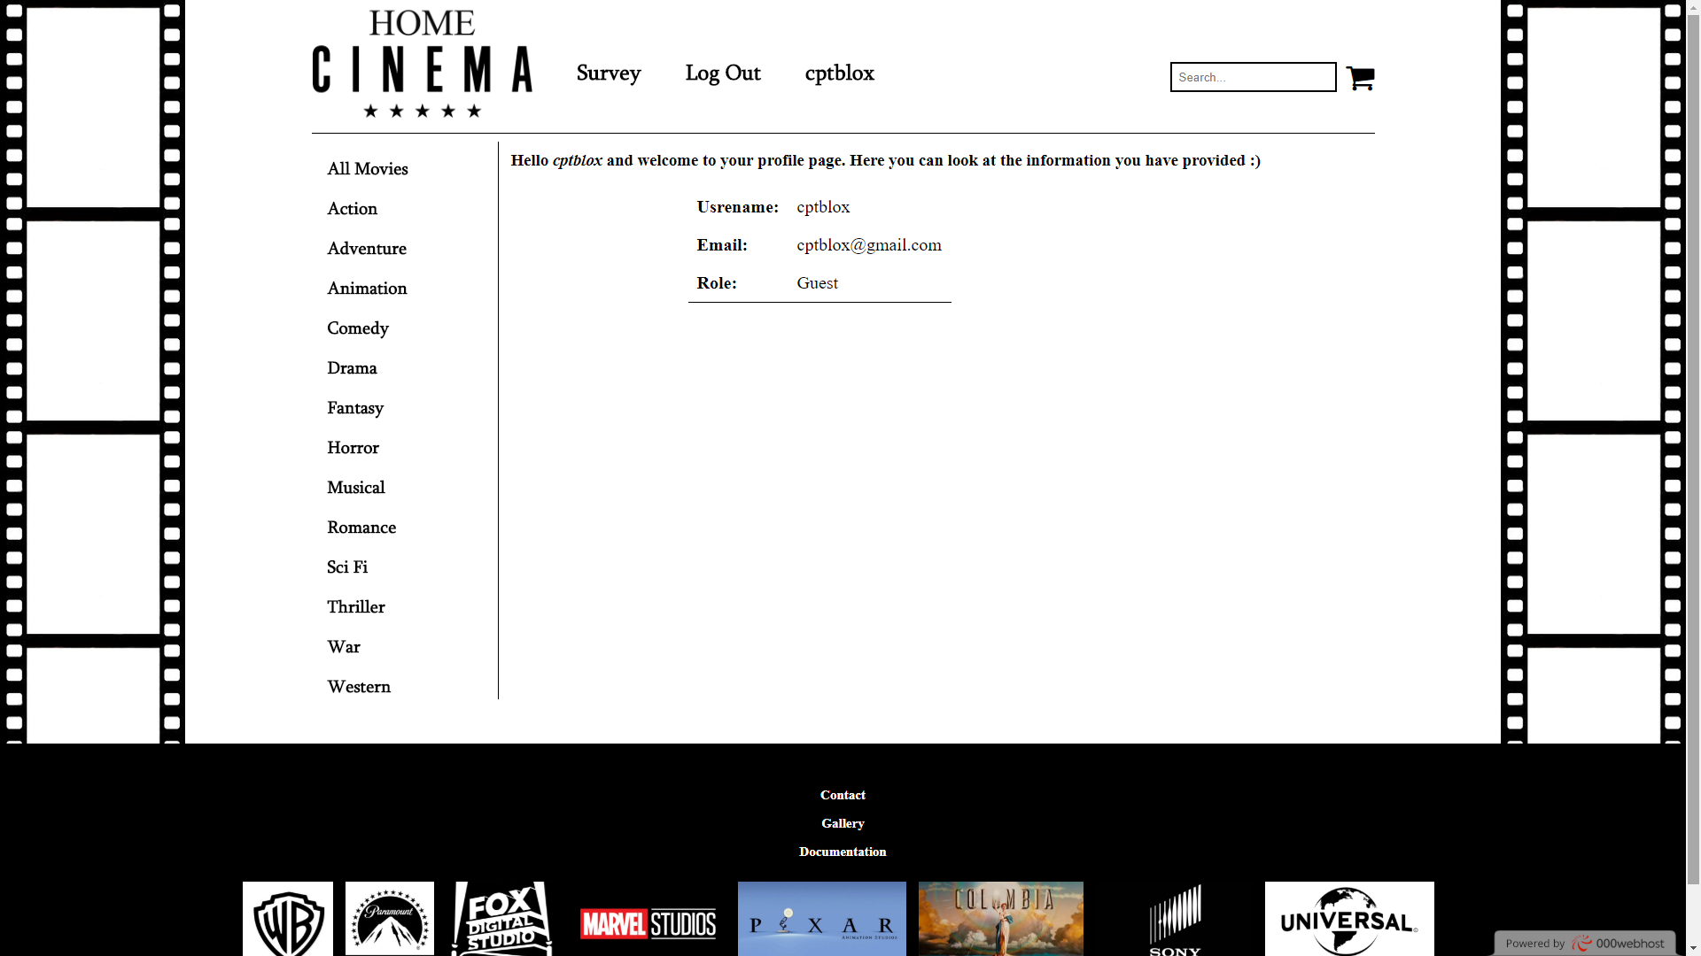

### 1.3.9 form.php?page=contact

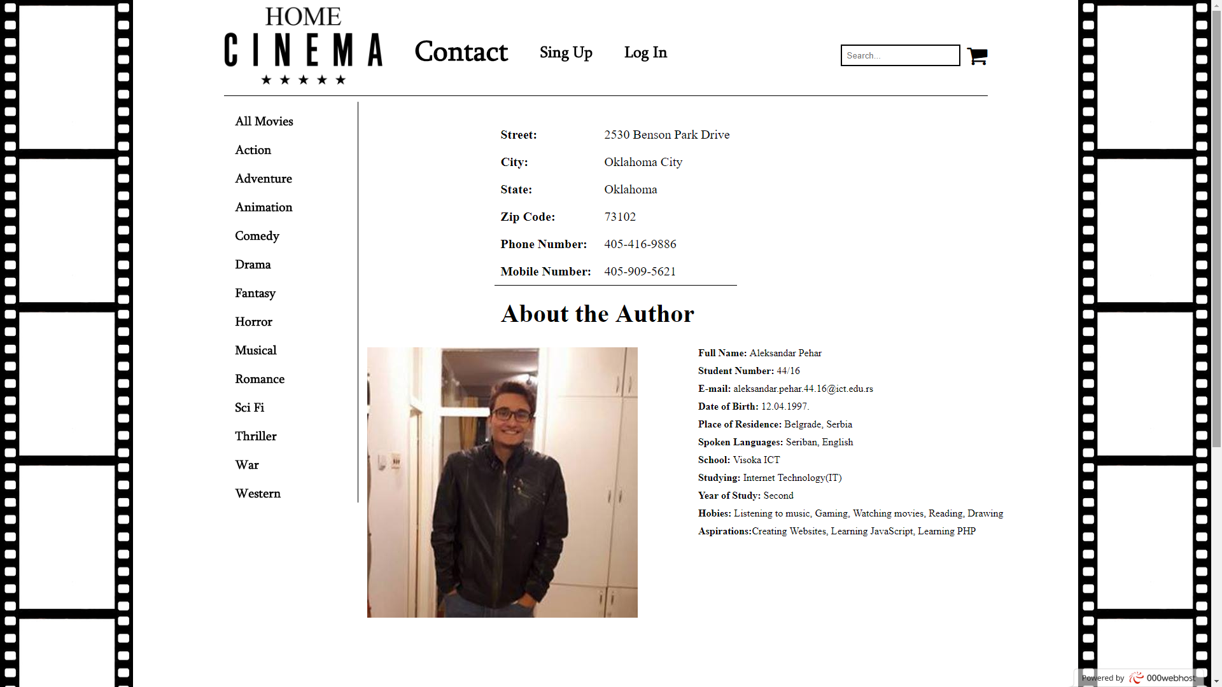

### 1.3.10 form.php?page=gallery

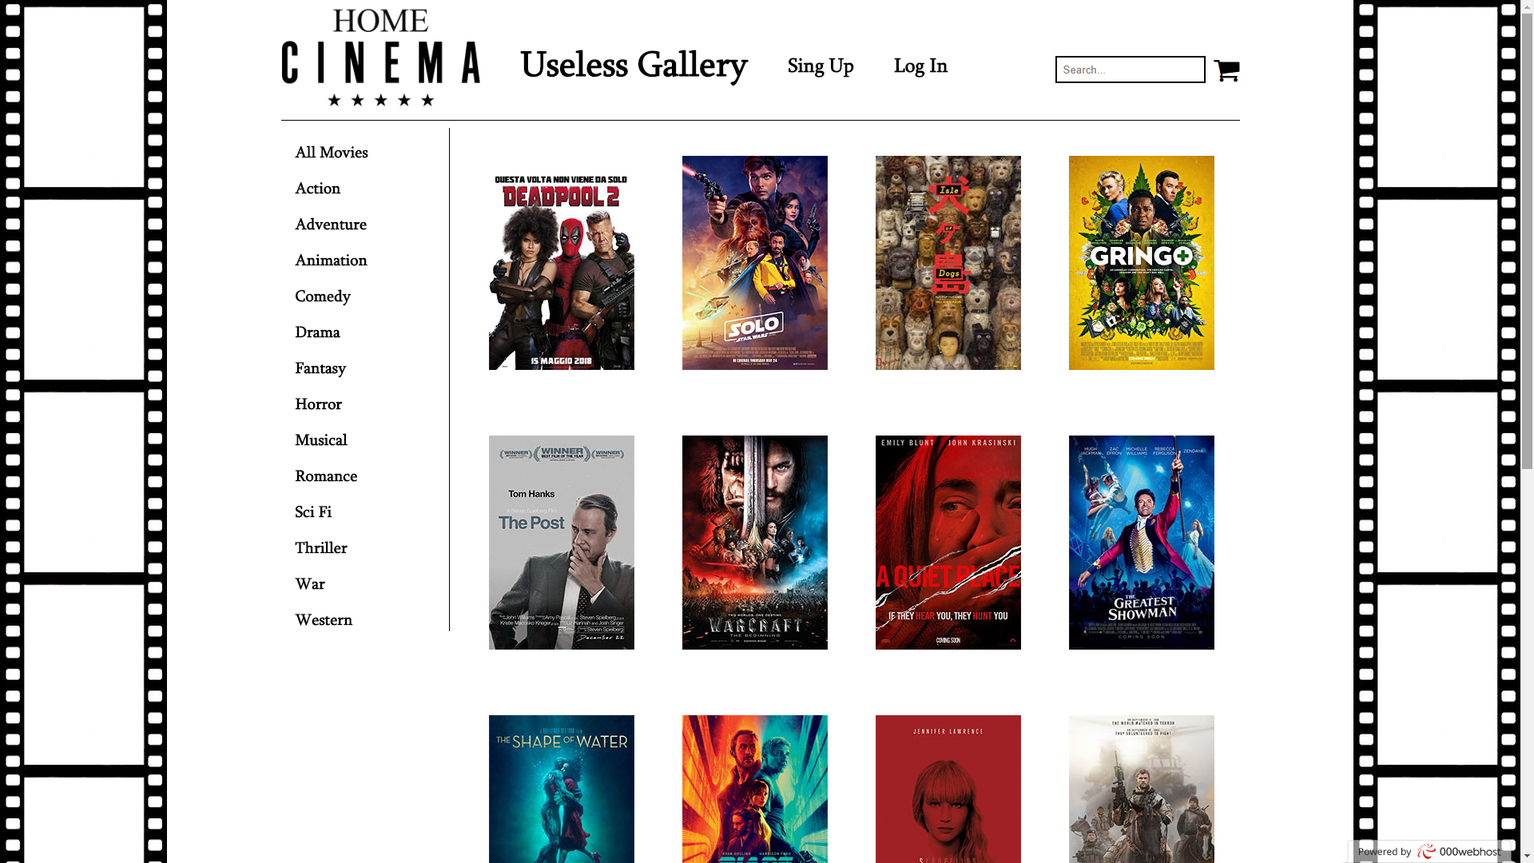

### 1.3.11 form.php? page=edit&user=”borj id-a”

### 

## Koriscenje CSS

* {

margin: 0px;

padding: 0px;

}

.cleaner {

clear: both;

}

a

{

    text-decoration:none;

}

ul

{

    list-style:none;

}

body

{

background-image: url('../img/film.png'), url('../img/film.png');

background-repeat: repeat-y, repeat-y;

background-position: right top, left top;

}

#wrapper

{

width: 1200px;

height: 100%;

margin: 0px auto;

}

#meni

{

height:150px;

width: 1200px;

border-bottom: 1px solid black;

position:fixed;

z-index: 10;

background: white;

}

#meni img

{

width: 250px;

float: left;

}

#meni h1

{

padding: 50px 0px 0px 50px;

font-family: 'Sylfaen Regular', 'Times New Roman', Times, serif;

font-size: 45px;

float: left;

color: black;

}

#meni h2 a

{

padding: 65px 0px 0px 50px;

font-family: 'Sylfaen Regular', 'Times New Roman', Times, serif;

font-size: 25px;

float: left;

}

#meni h2 a:hover

{

font-size: 28px;

}

#meni i

{

font-size: 35px;

padding-top: 70px;

float:right;

}

#search

{

padding: 8px;

margin: 70px 10px 0px 0px;

float:right;

border: 1.5px solid black;

}

#meni a

{

color:black;

}

#categorys

{

margin: 160px 0px 0px 10px;

width: 200px;

border-right: 1px solid black;

position:absolute;

}

#categorys a

{

font-family: 'Sylfaen Regular', 'Times New Roman', Times, serif;

font-size: 20px;

display: block;

margin-top:15px;

padding: 2px 0px 2px 8px;

color:black;

transition: background-color .3s;

}

#categorys a:hover

{

font-size: 23px;

background: black;

color:white;

}

#content

{

position: relative;

left:220px;

top:165px;

padding: 5px;

width: 1000px;

min-height: 600px;

}

.movie-block

{

float: left;

width: 182px;

height: 280px;

margin: 25px 25px 45px 35px;

}

.movie-block h3

{

padding: 5px;

margin-top: -55px;

text-align: center;

background: black;

font-size: 15px;

}

.movie-block a

{

color: white;

}

.movie-block a:hover

{

font-size: 16px;

}

.movie-tag

{

position: relative;

top: -273px;

left: -5px;

padding:5px;

background: black;

color: white;

}

.movie-year

{

position: relative;

top: -273px;

padding:5px;

background: black;

color: white;

}

.cart-add

{

position: relative;

top: -150px;

left:50px;

visibility:hidden;

}

.add

{

background: black;

color: white;

border: none;

padding: 10px;

font-size: 15px;

}

#footer

{

position: relative;

top:180px;

margin-top: 50px;

height: 100%;

width: 100%;

background: black;

padding: 50px 0px 50px 0px;

text-align: center;

}

#footer a

{

color:white;

font-size: 15px;

display: block;

padding-bottom: 15px;

}

#footer a:hover

{

font-size: 20px;

}

#sponsore img

{

height: 100px;

margin-top: 10px;

margin-right: 10px;

}

#headline h2

{

font-size: 40px;

}

iframe

{

width: 520px;

height: 345px;

margin: 20px 30px 150px 0px;

float: left;

}

#movie-info

{

margin-top:20px;

float: left;

width: 400px;

border-collapse: collapse;

}

#movie-info tr td

{

text-align: left;

vertical-align: top;

padding: 10px ;

border-bottom: 1px solid black;

}

#form

{

margin:20px 0px 350px 200px;

border-collapse: collapse;

padding:10px;

text-align: left;

border-bottom: 1.5px solid black;

}

#form tr td

{

font-size: 20px;

padding: 10px ;

}

#form input

{

padding: 5px 100px;

}

#form button

{

padding:12px 20px;

background: black;

color: white;

border: none;

}

#pagination

{

text-align: center;

padding: 15px;

margin-top: 710px;

}

#pagination a {

color: black;

padding: 8px 16px;

text-decoration: none;

transition: background-color .3s;

margin: 5px;

}

#pagination a:hover

{

background-color: black;

color: white;

}

#me

{

position: relative;

top:-300px;

float:left;

}

#aboutme

{

position: relative;

top:-300px;

float: right;

}

#aboutme li

{

margin-bottom: 10px;

}

.gallery

{

float: left;

width: 182px;

height: 280px;

margin: 25px 25px 45px 35px;

}

#minTitle

{

font-size: 40px;

position: relative;

top:-330px;

left:210px;

}

#edit

{

padding:10px;

background: black;

color: white;

border: none;

position: relative;

top:-330px;

left:200px;

}

#edit-tab

{

position: relative;

top: -300px;

visibility: hidden;

}

#form2

{

margin:20px 0px -200px 200px;

border-collapse: collapse;

padding:10px;

text-align: left;

}

#form2 tr td

{

font-size: 20px;

padding: 10px ;

}

#form2 input

{

padding: 5px 100px;

}

#form2 button

{

padding:12px 20px;

background: black;

color: white;

border: none;

}

.profile

{

border:1px solid black;

float:left;

padding:10px;

width: 350px;

margin: 20px 10px 0px 10px;

}

.profile-tab

{

border-collapse: collapse;

}

.profile-tab tr td

{

height: 30px;

border-bottom: 1px solid black;

vertical-align: bottom;

}

.profile-tab a

{

padding:5px 10px 1px 5px;

background: white;

color: black;

transition: background-color .3s;

}

.profile-tab a:hover

{

background: black;

color: white;

}

#favorite

{

margin-top: 20px;

margin-bottom: 450px;

}

#favorite h4

{

font-size: 30px;

}

#drop

{

padding:10px 20px 10px 20px;

}

#surveySubmit

{

padding: 10px;

border: 1px solid black;

background: white;

}

#surveySubmit:hover

{

background: black;

color: white;

}

#sorry

{

margin-bottom: 550px;

}

#message

{

position: relative;

top:-300px;

left:200px;

font-size: 30px;

color: red;

}

.delete

{

padding:5px 10px 1px 5px;

background: white;

color: #cc0000;

border: none;

transition: background-color .3s;

font-weight: bold;

font-size: 15px;

}

.delete:hover

{

background: black;

color: #cc0000;

}

#sent

{

font-size: 20px;

position: relative;

top:-300px;

left:200px;

color: green;

padding:5px 10px 5px 5px;

}

#sent a

{

color: black;

}

#sent a:hover

{

color: #cc0000;

}

# ORGANIZACIJA

## 2.1 Organizaciona shema

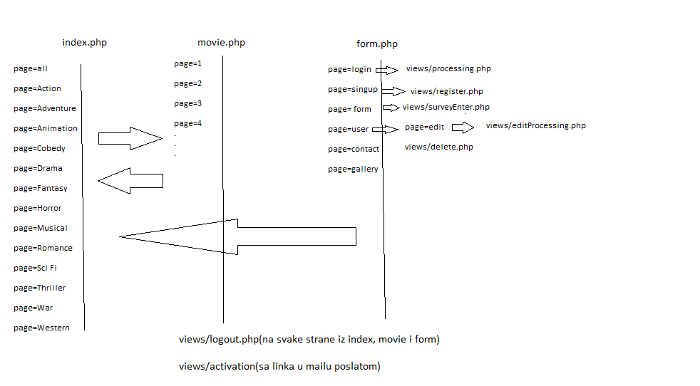

# KODOVI

## 3.1 JavaScript

$(document).ready(function(){

$(".movie-block").hover(function(){

$(".cart-add", this).css("visibility", "visible");

$(this).css("filter", "grayscale(70%)");

}, function(){

$(".cart-add", this).css("visibility", "hidden");

$(this).css("filter", "")

})

})

function edit()

{

var x = document.getElementById("edit-tab");

if (x.style.visibility === "hidden") {

x.style.visibility = "visible";

} else {

x.style.visibility = "hidden";

}

}

function regCheck()

{

var x = false;

var email = document.querySelector("#email").value;

var username = document.querySelector("#name").value;

var pass = document.querySelector("#pass").value;

var passCon = document.querySelector("#passCon").value;

var regEmail = /^(([^<>()\[\]\\.,;:\s@"]+(\.[^<>()\[\]\\.,;:\s@"]+)*)|(".+"))@((\[[0-9]{1,3}\.[0-9]{1,3}\.[0-9]{1,3}\.[0-9]{1,3}\])|(([a-zA-Z\-0-9]+\.)+[a-zA-Z]{2,}))$/;

var regName = /^[a-zA-Z0-9]{4,20}$/;

var regPass = /^[a-zA-Z0-9]{5,20}$/;

var errors = [];

if(!regEmail.test(email))

{

document.querySelector("#email").style.borderColor = "red";

errors.push("Emaile is not regular");

x = false;

}

else

{

document.querySelector("#email").style.borderColor = "green";

}

if(!regName.test(username))

{

document.querySelector("#name").style.borderColor = "red";

errors.push("Usrename is not regular")

x = false;

}

else

{

document.querySelector("#name").style.borderColor = "green";

}

if(!regPass.test(pass))

{

document.querySelector("#pass").style.borderColor = "red";

errors.push("Password is regular");

x = false;

}

else

{

document.querySelector("#pass").style.borderColor = "green";

}

if(pass != passCon || pass == "")

{

document.querySelector("#passCon").style.borderColor = "red";

errors.push("Passwords do not match");

x = false;

}

else if(pass == passCon)

{

document.querySelector("#passCon").style.borderColor = "green";

}

if(errors.length > 0)

{

//alert("ne moze");

x = false;

}

else{

//alert("ok");

x = true;

}

return x;

}

function editCheck3()

{

var x = true;

        var email = document.querySelector("#email").value;

var username = document.querySelector("#name").value;

var active = document.querySelector("#active").value;

var role = document.querySelector("#role").value;

var regEmail = /^(([^<>()\[\]\\.,;:\s@"]+(\.[^<>()\[\]\\.,;:\s@"]+)*)|(".+"))@((\[[0-9]{1,3}\.[0-9]{1,3}\.[0-9]{1,3}\.[0-9]{1,3}\])|(([a-zA-Z\-0-9]+\.)+[a-zA-Z]{2,}))$/;

var regName = /^[a-zA-Z0-9]{4,20}$/;

var errors = [];

if(!regEmail.test(email))

{

document.querySelector("#email").style.borderColor = "red";

errors.push(" Email is not regular");

x= false;

}

else

{

document.querySelector("#email").style.borderColor = "green";

x= true;

}

if(!regName.test(username))

{

document.querySelector("#name").style.borderColor = "red";

errors.push(" Usrename is not regular")

x= false;

}

else

{

document.querySelector("#name").style.borderColor = "green";

x= true;

}

if(active!=1 && active!=0)

{

document.querySelector("#active").style.borderColor = "red";

errors.push(" Active value is regular");

x= false;

}

else

{

document.querySelector("#active").style.borderColor = "green";

x= true;

}

if(role!="guest" && role!="admin")

{

document.querySelector("#role").style.borderColor = "red";

errors.push(" Role value is iregular");

x= false;

}

else

{

document.querySelector("#role").style.borderColor = "green";

x= true;

}

if(errors.length > 0)

{

var message = "<ul>";

for($i=0; $i<errors.length; $i++)

{

message+= "<li>"+ errors[$i] +"</li>";

}

message += "</ul>";

document.querySelector("#message").innerHTML = message;

x= false;

}

else

{

x= true;

}

//alert(x);

return x;

}

function surveyCheck()

{

var x = false;

var pick = document.querySelector("#drop").value;

if(pick=="0")

{

var pick = document.querySelector("#drop").style.borderColor = "red";

x = false

}

else

{

var pick = document.querySelector("#drop").style.borderColor = "green";

x = true;

}

//alert(x);

return x;

}

## PHP

### index.php

<?php

session_start();

require_once "php/connection.php";

if(!isset($_GET['page']))

{

header("Location: index.php?page=all");

}

include"views/header.php";

include"views/meni.php";

include"views/category.php";

include"views/content.php";

include"views/footer.php";

?>

### movie.php

1. <?php
2. session_start();
3. require_once "php/connection.php";
4. include"views/header.php";
5. include"views/meni.php";
6. include"views/category.php";
7. include"views/moviedetail.php";
9. include"views/footer.php";
10. ?>

### 3.2.3 form.php

<?php

session_start();

require_once "php/connection.php";

include"views/header.php";

include"views/meni.php";

include"views/category.php";

if(isset($_GET['page']))

{

$page = $_GET['page'];

switch($page)

{

case 'singup':

include"views/singup.php";

break;

case 'login':

include"views/login.php";

break;

case 'contact':

include"views/contact.php";

break;

case 'form':

include"views/form.php";

break;

case 'gallery':

case 'gallery2':

case 'gallery3':

case 'gallery4':

case 'gallery5':

case 'gallery6':

case 'gallery7':

case 'gallery8':

case 'gallery9':

include"views/gallery.php";

break;

case 'user':

include"views/user.php";

break;

case 'edit':

include"views/edit.php";

break;

}

}

include"views/footer.php";

?>

### 3.2.4 php/connection.php

<?php

$serverBaze = 'localhost';

$username = 'id6242216_homeadmin';

$password = 'Kalgon123';

$bazaPodataka = 'id6242216_homecinema';

try{

$connect = new PDO("mysql:host=$serverBaze;dbname=$bazaPodataka", $username, $password);

$connect->setAttribute(PDO::ATTR_ERRMODE, PDO::ERRMODE_EXCEPTION);

}

catch(PDOException $x)

{

echo $x->getMessage;

}

?>

### 3.2.5 views/header.php

<!DOCTYPE html>

<html lang="en">

<head>

<meta charset="UTF-8">

<meta http-equiv="X-UA-Compatible" content="ie=edge">

<meta name="description" content="Free Web tutorials">

<meta name="keywords" content="HTML,CSS,XML,JavaScript,PHP">

<meta name="author" content="Aleksandar Pehar">

<meta name="viewport" content="width=device-width, initial-scale=1.0">

<link rel="stylesheet" href="https://cdnjs.cloudflare.com/ajax/libs/font-awesome/4.7.0/css/font-awesome.min.css">

<link rel="icon" href="img/icon.jpg"/>

<link rel="stylesheet" href="css/style.css">

<title>Home Cinema</title>

</head>

### 3.2.6 views/meni.php

<body>

<div id="wrapper">

<div id="meni">

<a href="index.php?page=all"><img src="img/logo.png" alt="logo"></a>

<?php

if(isset($_GET['page']))

{

$page = $_GET['page'];

switch($page)

{

case 'all':

case 'all2':

case 'all3':

case 'all4':

case 'all5':

case 'all6':

case 'all7':

case 'all8':

echo "<h1>All Movies</h1>";

break;

case 'Action':

case 'Action2':

case 'Action3':

case 'Action4':

case 'Action5':

case 'Action6':

case 'Action7':

case 'Action8':

echo "<h1>Action</h1>";

break;

case 'Adventure':

case 'Adventure2':

case 'Adventure3':

case 'Adventure4':

case 'Adventure5':

case 'Adventure6':

case 'Adventure7':

case 'Adventure8':

echo "<h1>Adventure</h1>";

break;

case 'Animation':

case 'Animation2':

case 'Animation3':

case 'Animation4':

case 'Animation5':

case 'Animation6':

case 'Animation7':

case 'Animation8':

echo "<h1>Animation</h1>";

break;

case 'Comedy':

case 'Comedy2':

case 'Comedy3':

case 'Comedy4':

case 'Comedy5':

case 'Comedy6':

case 'Comedy7':

case 'Comedy8':

echo "<h1>Comedy</h1>";

break;

case 'Drama':

case 'Drama2':

case 'Drama3':

case 'Drama4':

case 'Drama5':

case 'Drama6':

case 'Drama7':

case 'Drama8':

echo "<h1>Drama</h1>";

break;

case 'Fantasy':

case 'Fantasy2':

case 'Fantasy3':

case 'Fantasy4':

case 'Fantasy5':

case 'Fantasy6':

case 'Fantasy7':

case 'Fantasy8':

echo "<h1>Fantasy</h1>";

break;

case 'Horror':

case 'Horror2':

case 'Horror3':

case 'Horror4':

case 'Horror5':

case 'Horror6':

case 'Horror7':

case 'Horror8':

echo "<h1>Horror</h1>";

break;

case 'Musical':

case 'Musical2':

case 'Musical3':

case 'Musical4':

case 'Musical5':

case 'Musical6':

case 'Musical7':

case 'Musical8':

echo "<h1>Musical</h1>";

break;

case 'Romance':

case 'Romance2':

case 'Romance3':

case 'Romance4':

case 'Romance5':

case 'Romance6':

case 'Romance7':

case 'Romance8':

echo "<h1>Romance</h1>";

break;

case 'Sci Fi':

case 'Sci Fi2':

case 'Sci Fi3':

case 'Sci Fi4':

case 'Sci Fi5':

case 'Sci Fi6':

case 'Sci Fi7':

case 'Sci Fi8':

echo "<h1>Sci-Fi</h1>";

break;

case 'Thriller':

case 'Thriller2':

case 'Thriller3':

case 'Thriller4':

case 'Thriller5':

case 'Thriller6':

case 'Thriller7':

case 'Thriller8':

echo "<h1>Thriller</h1>";

break;

case 'War':

case 'War2':

case 'War3':

case 'War4':

case 'War5':

case 'War6':

case 'War7':

case 'War8':

echo "<h1>War</h1>";

break;

case 'Western':

case 'Western2':

case 'Western3':

case 'Western4':

case 'Western5':

case 'Western6':

case 'Western7':

case 'Western8':

echo "<h1>Western</h1>";

break;

case 'singup':

echo "<h1>Sing Up</h1>";

break;

case 'login':

echo "<h1>Log In</h1>";

break;

case 'contact':

echo "<h1>Contact</h1>";

break;

case 'gallery':

case 'gallery':

case 'gallery2':

case 'gallery3':

case 'gallery4':

case 'gallery5':

case 'gallery6':

case 'gallery7':

case 'gallery8':

case 'gallery9':

echo "<h1>Useless Gallery</h1>";

break;

case 'form':

echo "<h1>Survey</h1>";

break;

}

}

if($connect)

{

$query = "SELECT * FROM meni";

$meni = $connect->query($query)->fetchAll();

if(count($meni)>0)

{

if(isset($_SESSION['user']))

{

$user = $_SESSION['user'];

foreach($meni as $tab)

{

if($page=="form")

{

if($tab['href']!="form" && $tab['href']!="singup" && $tab['href']!="login")

{

echo "<h2><a href='form.php?page=" . $tab['href'] . "'>" . $tab['name'] ."</a></h2>";

}

}

if($page!="form" )

{

if($tab['href']!="singup" && $tab['href']!="login")

{

echo "<h2><a href='form.php?page=" . $tab['href'] . "'>" . $tab['name'] ."</a></h2>";

}

}

}

echo "<h2><a href='views/logout.php'>Log Out</a></h2>";

echo "<h2><a href='form.php?page=user'>" . $user['username'] ."</a></h2>";

}

else{

foreach($meni as $tab)

{

if($page=="login")

{

if($tab['href']!="form" && $tab['href']!="login")

{

echo "<h2><a href='form.php?page=" . $tab['href'] . "'>" . $tab['name'] ."</a></h2>";

}

}

else if($page=="singup")

{

if($tab['href']!="form" && $tab['href']!="singup")

{

echo "<h2><a href='form.php?page=" . $tab['href'] . "'>" . $tab['name'] ."</a></h2>";

}

}

else

{

if($tab['href']!="form")

{

echo "<h2><a href='form.php?page=" . $tab['href'] . "'>" . $tab['name'] ."</a></h2>";

}

}

}

}

}

}

?>

<form method="#" action="#">

<a href="#"><i class="fa fa-shopping-cart"></i></a>

<input type="text" placeholder="Search..." name="search" id="search">

</form>

</div>

<div class="cleaner"></div>

### 3.2.7 views/category.php

<div id="categorys">

<h2><a href="index.php?page=all">All Movies</a></h2>

<?php

if($connect)

{

$query = "SELECT * FROM genres";

$categories = $connect->query($query)->fetchAll();

if(count($categories)>0)

{

foreach($categories as $row)

{

echo "<h2><a href='index.php?page=" . $row['name'] . "'>" . $row['name'] ."</a></h2>";

}

}

}

?>

</div>

<div class="cleaner"></div>

### 3.2.8 views/footer.php

<div id="footer">

<h6><a href="form.php?page=contact">Contact</a> </h6>

<h6><a href="form.php?page=gallery">Gallery</a> </h6>

<h6> <a href="#">Documentation</a> </h6>

<span id="sponsore">

<img class="studio" src="img/studio1.jpg" alt="#">

<img class="studio" src="img/studio2.jpg" alt="#">

<img class="studio" src="img/studio3.jpg" alt="#">

<img class="studio" src="img/studio4.jpg" alt="#">

<img class="studio" src="img/studio5.jpg" alt="#">

<img class="studio" src="img/studio6.jpg" alt="#">

<img class="studio" src="img/studio7.jpg" alt="#">

<img class="studio" src="img/studio8.jpg" alt="#">

</span>

</div>

</body>

<script src="js/jquery.js"></script>

<script src="js/script.js"></script>

</html>

### 3.2.8 views/content.php

<div id="content"><?php

if(isset($_GET['page'])):

$page = $_GET['page'];

include 'views/switch.php';

$rowCount = $connect->query($rowQuery)->fetch();

$number_of_rows = $rowCount['rowCount'];

$rows_per_page = 16;

$number_of_pages = ceil($number_of_rows / $rows_per_page);

$list = $connect->query($query)->fetchAll();

if(count($list)>0):

foreach($list as $movie):

?>

<div class="movie-block">

<a href="movie.php?page=<?php echo $movie['id_movies']?>"><img src="img/<?php echo $movie['image']?>" alt="<?php echo $movie['name']?>"></a>

<span class="movie-tag"><?php echo $movie['gName']?></span>

<span class="movie-year"><?php echo $movie['year']?></span>

<span class="cart-add">

<form action="#" method="#">

<button class="add" type="button">Add to Cart</button>

</form>

</span>

<h3>

<a href="movie.php?page=<?php echo $movie['id_movies']?>"><?php echo $movie['mName'] . " (" . $movie['copies'] . ")"?></a>

</h3>

</div>

<?php endforeach; endif;

else:

header("Location: index.php?page=all");

endif;

$startingGroup = ['all', 'Action', 'Adventure', 'Animation', 'Comedy', 'Drama', 'Fantasy', 'Horror', 'Musical', 'Romance', 'Sci Fi', 'Thriller', 'War', 'Western', 'gallery'];

if($number_of_pages > 1)

{

echo "<div id='pagination'>";

if(in_array($page, $startingGroup))

{

echo "<a href='index.php?page=". $page ."'>1</a>";

}

else

{

echo "<a href='index.php?page=". substr($page, 0, -1) ."'>1</a>";

}

//echo "<a href='index.php?page=". $page ."'>1</a>";

for($i=2; $i<=$number_of_pages; $i++)

{

if(!in_array($page, $startingGroup))

{

echo "<a href='index.php?page=". substr($page, 0, -1) . $i ."'>$i</a>";

}

else

{

echo "<a href='index.php?page=". $page . $i ."'>$i</a>";

}

}

echo "</div>";

}

// echo substr('a,b,c,d,e,', 0, -1)

?>

</div>

</div>

<div class="cleaner"></div>

### 3.2.9 views/switch.php

<?php

switch($page){

case 'all':

$query = "SELECT *, g.name AS gName, m.name AS mName FROM movies m INNER JOIN genres g ON m.genre_id = g.id_genre ORDER BY m.year DESC LIMIT 0,16";

$rowQuery = "SELECT COUNT(*) AS rowCount FROM movies";

break;

case 'all2':

$query = "SELECT *, g.name AS gName, m.name AS mName FROM movies m INNER JOIN genres g ON m.genre_id = g.id_genre ORDER BY m.year DESC LIMIT 16,16";

$rowQuery = "SELECT COUNT(*) AS rowCount FROM movies";

break;

case 'all3':

$query = "SELECT *, g.name AS gName, m.name AS mName FROM movies m INNER JOIN genres g ON m.genre_id = g.id_genre ORDER BY m.year DESC LIMIT 32,16";

$rowQuery = "SELECT COUNT(*) AS rowCount FROM movies";

break;

case 'all4':

$query = "SELECT *, g.name AS gName, m.name AS mName FROM movies m INNER JOIN genres g ON m.genre_id = g.id_genre ORDER BY m.year DESC LIMIT 48,16";

$rowQuery = "SELECT COUNT(*) AS rowCount FROM movies";

break;

case 'all5':

$query = "SELECT *, g.name AS gName, m.name AS mName FROM movies m INNER JOIN genres g ON m.genre_id = g.id_genre ORDER BY m.year DESC LIMIT 64,16";

$rowQuery = "SELECT COUNT(*) AS rowCount FROM movies";

break;

case 'all6':

$query = "SELECT *, g.name AS gName, m.name AS mName FROM movies m INNER JOIN genres g ON m.genre_id = g.id_genre ORDER BY m.year DESC LIMIT 80,16";

$rowQuery = "SELECT COUNT(*) AS rowCount FROM movies";

break;

case 'all7':

$query = "SELECT *, g.name AS gName, m.name AS mName FROM movies m INNER JOIN genres g ON m.genre_id = g.id_genre ORDER BY m.year DESC LIMIT 96,16";

$rowQuery = "SELECT COUNT(*) AS rowCount FROM movies";

break;

case 'all8':

$query = "SELECT *, g.name AS gName, m.name AS mName FROM movies m INNER JOIN genres g ON m.genre_id = g.id_genre ORDER BY m.year DESC LIMIT 112,16";

$rowQuery = "SELECT COUNT(*) AS rowCount FROM movies";

break;

case 'all9':

$query = "SELECT *, g.name AS gName, m.name AS mName FROM movies m INNER JOIN genres g ON m.genre_id = g.id_genre ORDER BY m.year DESC LIMIT 128,16";

$rowQuery = "SELECT COUNT(*) AS rowCount FROM movies";

break;

case 'Action':

$query = "SELECT *, g.name AS gName, m.name AS mName FROM movies m INNER JOIN genres g ON m.genre_id = g.id_genre WHERE m.genre_id = 1 LIMIT 0,8";

$rowQuery = "SELECT COUNT(*) AS rowCount FROM movies WHERE genre_id = 1";

break;

case 'Action8':

$query = "SELECT *, g.name AS gName, m.name AS mName FROM movies m INNER JOIN genres g ON m.genre_id = g.id_genre WHERE m.genre_id = 1 LIMIT 56,8";

$rowQuery = "SELECT COUNT(*) AS rowCount FROM movies WHERE genre_id = 1";

break;

case 'Adventure':

$query = "SELECT *, g.name AS gName, m.name AS mName FROM movies m INNER JOIN genres g ON m.genre_id = g.id_genre WHERE m.genre_id = 2 LIMIT 0,16";

$rowQuery = "SELECT COUNT(*) AS rowCount FROM movies WHERE genre_id = 2";

break;

case 'Animation':

$query = "SELECT *, g.name AS gName, m.name AS mName FROM movies m INNER JOIN genres g ON m.genre_id = g.id_genre WHERE m.genre_id = 3 LIMIT 0,16";

$rowQuery = "SELECT COUNT(*) AS rowCount FROM movies WHERE genre_id = 3";

break;

case 'Comedy':

$query = "SELECT *, g.name AS gName, m.name AS mName FROM movies m INNER JOIN genres g ON m.genre_id = g.id_genre WHERE m.genre_id = 4 LIMIT 0,16";

$rowQuery = "SELECT COUNT(*) AS rowCount FROM movies WHERE genre_id = 4";

break;

case 'Drama':

$query = "SELECT *, g.name AS gName, m.name AS mName FROM movies m INNER JOIN genres g ON m.genre_id = g.id_genre WHERE m.genre_id = 5 LIMIT 0,16";

$rowQuery = "SELECT COUNT(*) AS rowCount FROM movies WHERE genre_id = 5";

break;

case 'Fantasy':

$query = "SELECT *, g.name AS gName, m.name AS mName FROM movies m INNER JOIN genres g ON m.genre_id = g.id_genre WHERE m.genre_id = 6 LIMIT 0,16";

$rowQuery = "SELECT COUNT(*) AS rowCount FROM movies WHERE genre_id = 6";

break;

case 'Horror':

$query = "SELECT *, g.name AS gName, m.name AS mName FROM movies m INNER JOIN genres g ON m.genre_id = g.id_genre WHERE m.genre_id = 7 LIMIT 0,16";

$rowQuery = "SELECT COUNT(*) AS rowCount FROM movies WHERE genre_id = 7";

break;

case 'Musical':

$query = "SELECT *, g.name AS gName, m.name AS mName FROM movies m INNER JOIN genres g ON m.genre_id = g.id_genre WHERE m.genre_id = 8 LIMIT 0,16";

$rowQuery = "SELECT COUNT(*) AS rowCount FROM movies WHERE genre_id = 8";

break;

case 'Romance':

$query = "SELECT *, g.name AS gName, m.name AS mName FROM movies m INNER JOIN genres g ON m.genre_id = g.id_genre WHERE m.genre_id = 9 LIMIT 0,16";

$rowQuery = "SELECT COUNT(*) AS rowCount FROM movies WHERE genre_id = 9";

break;

case 'Sci Fi':

$query = "SELECT *, g.name AS gName, m.name AS mName FROM movies m INNER JOIN genres g ON m.genre_id = g.id_genre WHERE m.genre_id = 10 LIMIT 0,16";

$rowQuery = "SELECT COUNT(*) AS rowCount FROM movies WHERE genre_id = 10";

break;

case 'Thriller':

$query = "SELECT *, g.name AS gName, m.name AS mName FROM movies m INNER JOIN genres g ON m.genre_id = g.id_genre WHERE m.genre_id = 11 LIMIT 0,16";

$rowQuery = "SELECT COUNT(*) AS rowCount FROM movies WHERE genre_id = 11";

break;

case 'War':

$query = "SELECT *, g.name AS gName, m.name AS mName FROM movies m INNER JOIN genres g ON m.genre_id = g.id_genre WHERE m.genre_id = 12 LIMIT 0,16";

$rowQuery = "SELECT COUNT(*) AS rowCount FROM movies WHERE genre_id = 12";

break;

case 'Western':

$query = "SELECT *, g.name AS gName, m.name AS mName FROM movies m INNER JOIN genres g ON m.genre_id = g.id_genre WHERE m.genre_id = 13 LIMIT 0,16";

$rowQuery = "SELECT COUNT(*) AS rowCount FROM movies WHERE genre_id = 13";

break;

case 'gallery':

$query = "SELECT * FROM movies LIMIT 0,16";

$rowQuery = "SELECT COUNT(*) AS rowCount FROM movies";

break;

case 'gallery2':

$query = "SELECT * FROM movies LIMIT 16,16";

$rowQuery = "SELECT COUNT(*) AS rowCount FROM movies";

break;

case 'gallery3':

$query = "SELECT * FROM movies LIMIT 32,16";

$rowQuery = "SELECT COUNT(*) AS rowCount FROM movies";

break;

case 'gallery4':

$query = "SELECT * FROM movies LIMIT 48,16";

$rowQuery = "SELECT COUNT(*) AS rowCount FROM movies";

break;

case 'gallery5':

$query = "SELECT * FROM movies LIMIT 64,16";

$rowQuery = "SELECT COUNT(*) AS rowCount FROM movies";

break;

case 'gallery6':

$query = "SELECT * FROM movies LIMIT 80,16";

$rowQuery = "SELECT COUNT(*) AS rowCount FROM movies";

break;

case 'gallery7':

$query = "SELECT * FROM movies LIMIT 96,16";

$rowQuery = "SELECT COUNT(*) AS rowCount FROM movies";

break;

case 'gallery8':

$query = "SELECT * FROM movies LIMIT 112,16";

$rowQuery = "SELECT COUNT(*) AS rowCount FROM movies";

break;

case 'gallery9':

$query = "SELECT * FROM movies LIMIT 128,16";

$rowQuery = "SELECT COUNT(*) AS rowCount FROM movies";

break;

}

?>

### 3.2.10 views/moviedetail.php

<div id="content">

<?php

if(isset($_GET['page'])):

$movie = $_GET['page'];

//if($movie == 0):

for($i=1; $i<200; $i++):

if($movie == $i):

$query = "SELECT * FROM movies WHERE id_movies = $i";

$detail = $connect->query($query)->fetch();

?>

<span id="headline">

<h2><?php echo $detail['name']?></h2>

</span>

<iframe src="<?php echo $detail['video']?>"></iframe>

<table id="movie-info">

<tr>

<td><b>Copies:</b></td>

<td><?php echo $detail['copies']?></td>

</tr>

<tr>

<td><b>Year:</b></td>

<td><?php echo $detail['year']?></td>

</tr>

<tr>

<td><b>Description:</b></td>

<td><?php echo $detail['info']?></td>

</tr>

<?php

if(isset($_SESSION['user'])):

$surveyQuery = "SELECT COUNT(*) AS score FROM movies m INNER JOIN users u ON m.id_movies = u.movies_id WHERE u.movies_id = $i";

$survey = $connect->query($surveyQuery)->fetch();

?>

<tr>

<td><b>Survey Score:</b></td>

<td><?php echo $survey['score']?> points</td>

</tr>

<?php endif;?>

<tr>

<td>

<form action="#" method="#">

<button class="add" type="button">Add to Cart</button>

</form>

</td>

<td></td>

</tr>

</table>

<?php

endif;endfor; endif;

?>

</div>

</div>

<div class="cleaner"></div>

### 3.2.11 views/gallery.php

<div id="content">

<?php

if(isset($_GET['page'])):

$page = $_GET['page'];

//

include 'views/switch.php';

$rowCount = $connect->query($rowQuery)->fetch();

$number_of_rows = $rowCount['rowCount'];

$rows_per_page = 16;

$number_of_pages = ceil($number_of_rows / $rows_per_page);

$list = $connect->query($query)->fetchAll();

if(count($list)>0):

foreach($list as $movie):

?>

<div class="gallery">

<img src="img/<?php echo $movie['image']?>" alt="<?php echo $movie['name']?>">

</div>

<?php endforeach; endif;

endif;

$startingGroup = ['all', 'Action', 'Adventure', 'Animation', 'Comedy', 'Drama', 'Fantasy', 'Horror', 'Musical', 'Romance', 'Sci Fi', 'Thriller', 'War', 'Western', 'gallery'];

if($number_of_pages > 1)

{

echo "<div id='pagination'>";

if(in_array($page, $startingGroup))

{

echo "<a href='form.php?page=". $page ."'>1</a>";

}

else

{

echo "<a href='form.php?page=". substr($page, 0, -1) ."'>1</a>";

}

//echo "<a href='index.php?page=". $page ."'>1</a>";

for($i=2; $i<=$number_of_pages; $i++)

{

if(!in_array($page, $startingGroup))

{

echo "<a href='form.php?page=". substr($page, 0, -1) . $i ."'>$i</a>";

}

else

{

echo "<a href='form.php?page=". $page . $i ."'>$i</a>";

}

}

echo "</div>";

}

// echo substr('a,b,c,d,e,', 0, -1)

?>

</div>

</div>

<div class="cleaner"></div>

### 3.2.11 views/contact.php

<div id="content">

<table id="form">

<tr>

<td><b>Street:</b></td>

<td>

2530 Benson Park Drive

</td>

</tr>

<tr>

<td><b>City:</b></td>

<td>

Oklahoma City

</td>

</tr>

<tr>

<td><b>State:</b></td>

<td>

Oklahoma

</td>

</tr>

<tr>

<td><b>Zip Code:</b></td>

<td>

73102

</td>

</tr>

<tr>

<td><b>Phone Number:</b></td>

<td>

405-416-9886

</td>

</tr>

<tr>

<td><b>Mobile Number:</b></td>

<td>

405-909-5621

</td>

</tr>

</table>

<h4 id="minTitle">About the Author</h4>

<img src="img/me.jpg" alt="me" id="me">

<ul id="aboutme">

<li><p><b>Full Name:</b> Aleksandar Pehar</p></li>

<li><p><b>Student Number:</b> 44/16</p></li>

<li><p><b>E-mail:</b> aleksandar.pehar.44.16@ict.edu.rs</p></li>

<li><p><b>Date of Birth:</b> 12.04.1997.</p></li>

<li><p><b>Place of Residence:</b> Belgrade, Serbia</p></li>

<li><p><b>Spoken Languages:</b> Seriban, English</p></li>

<li><p><b>School:</b> Visoka ICT</p></li>

<li><p><b>Studying:</b> Internet Technology(IT)</p></li>

<li><p><b>Year of Study:</b> Second</p></li>

<li><p><b>Hobies:</b> Listening to music, Gaming, Watching movies, Reading, Drawing</p></li>

<li><p><b>Aspirations:</b>Creating Websites, Learning JavaScript, Learning PHP</p></li>

</ul>

</div>

</div>

<div class="cleaner"></div>

### 3.2.12 views/singup.php

<div id="content">

<form method="POST" onsubmit="return regCheck();" action="views/register.php">

<table id="form">

<tr>

<td><b>Email:</b></td>

<td>

<input type="text" name="email" id="email">

</td>

</tr>

<tr>

<td><b>Username:</b></td>

<td>

<input type="text" name="name" id="name">

</td>

</tr>

<tr>

<td><b>Password:</b></td>

<td>

<input type="password" name="pass" id="pass">

</td>

</tr>

<tr>

<td><b>Confirm Password:</b></td>

<td>

<input type="password" name="passCon" id="passCon">

</td>

</tr>

<tr>

<td></td>

<td>

<button type="reset">Clear</button>

<button type="submit" name="sub" >Submit</button>

</td>

</tr>

</table>

</form>

<?php

if(isset($_GET['sent']))

{

echo "<h4 id='sent'>A validation has been sent to your email. Please validate it to <a href='form.php?page=login'>log in</a></h4>";

}

?>

</div>

</div>

<div class="cleaner"></div>

### 3.2.13 views/register.php

<?php

session_start();

require_once "../php/connection.php";

use PHPMailer\PHPMailer\PHPMailer;

use PHPMailer\PHPMailer\Exception;

require '../php/php_mailer/src/Exception.php';

require '../php/php_mailer/src/PHPMailer.php';

require '../php/php_mailer/src/SMTP.php';

if(isset($_POST['sub']))

{

$email = $_POST['email'];

$username = $_POST['name'];

$pass = $_POST['pass'];

$regUsername = "/^[a-zA-Z0-9]{4,20}$/";

$regPass = "/^[a-zA-Z0-9]{5,20}$/";

$errors = [];

if(!filter_var($email, FILTER_VALIDATE_EMAIL))

     {

         $errors[] = "Email not valid";

     }

     if(!preg_match($regUsername, $username))

     {

         $errors[] = "Username not valid";

}

if(!preg_match($regPass, $pass))

     {

         $errors[] = "Password not valid";

}

if(count($errors)>0)

     {

         var_dump($errors);

         //header("Location: form.php?page=user");

     }

     else

     {

$pass = md5($pass);

//echo $pass;

$token = md5(time() . $email);

$insert = "INSERT INTO users (username, email, pass, active, form, token, role_id) VALUES (:user, :email, :pass, 0, 0, :token, 2)";

$in = $connect->prepare($insert);

$in->bindParam(':user', $username);

$in->bindParam(':email', $email);

$in->bindParam(':pass', $pass);

     $in->bindParam(':token', $token);

try{

$try = $in->execute();

//echo "pa sine";

if($try){

$mail = new PHPMailer(true);

$mail->isSMTP();

$mail->Host = 'smtp.gmail.com';

$mail->SMTPAuth = true;

$mail->Username = 'homecinemaproject1337@gmail.com';

$mail->Password = 'Kalgon123';

$mail->SMTPSecure = 'tls';

$mail->Port = 587;

$mail->SMTPOptions = array(

'ssl' => array(

'verify_peer' => false,

'verify_peer_name' => false,

'allow_self_signed' => true

)

);

//Recipients

$mail->setFrom('homecinemaproject1337@gmail.com', 'Registration Form');

$mail->addAddress($email);

//Content

$mail->isHTML(true);

$mail->Subject = 'Activate your account';

$href = "homecinemaproject1337.000webhostapp.com/views/activation.php?token=" . $token;

$mail->Body = '<h1>Home Cinema</h1><br/><br/>If you want to activate your account, click the link: <a href="' . $href . '">HERE</a>';

$mail->send();

//echo "to";

header("Location: ../form.php?page=singup&sent=yes");

} else {

$statusCode = 500;

}

}

catch(PDOException $e){

$statusCode = 500;

//echo "catch";

}

        }

    }

?>

### 3.2.14 views/activation.php

<?php

session_start();

require_once "../php/connection.php";

$token = $_GET['token'];

$query = "UPDATE users SET active = 1 WHERE token = :token";

$activate = $connect->prepare($query);

$activate->bindParam(':token', $token);

    //echo $query;

    try{

 $try = $activate->execute();

if($try){

            //echo $query;

$statusCode = 204;

header("Location: ../form.php?page=login");

} else {

$statusCode = 500;

}

}

catch(PDOException $e){

$statusCode = 500;

//echo "catch";

    }

?>

### 3.2.14 views/login.php

<div id="content">

<form method="POST" action="views/processing.php">

<table id="form">

<tr>

<td><b>Email:</b></td>

<td>

<input type="text" name="email">

</td>

</tr>

<tr>

<td><b>Password:</b></td>

<td>

<input type="password" name="pass">

</td>

</tr>

<tr>

<td></td>

<td>

<button type="reset">Clear</button>

<button type="submit">Log In</button>

</td>

</tr>

</table>

</form>

<?php

if(isset($_GET['try']))

{

echo "<h4 id='sent'>The username or password is inccorect</h4>";

}

?>

</div>

</div>

<div class="cleaner"></div>

### 3.2.15 views/processing.php

<?php

session_start();

require_once "../php/connection.php";

$email = $_POST['email'];

$pass = md5($_POST['pass']);

//echo $pass;

$query = "SELECT * FROM users WHERE email = ? AND pass = ? AND active = 1";

$stmt = $connect->prepare($query);

try{

$stmt->execute([$email, $pass]);

$log = $stmt->fetch();

if(count($stmt) == 1)

{

//echo "Uspeso ste ulogovani";

$_SESSION['user'] = $log;

//var_dump($log);

$user = $_SESSION['user'];

//var_dump($user);

header("Location: ../index.php?page=all");

}

else

{

//echo "ne moze";

header("Location: ../form.php?page=login&try=yes");

}

}

catch(PDOException $e){

$statusCode = 500;

}

?>

### 3.2.16. views/form.php

<div id="content">

<?php

$username = $user['username'];

if($user['form']==0):

echo "<h3>Hello <i>$username</i> and welcome to a one time survey. All poits can be seen on every individual movie page :)</h3>";

?>

<div id="favorite">

<h4>What is your favorite movie:</h4>

<form method="POST" onsubmit="return surveyCheck();" action="views/surveyEnter.php">

<select id="drop" name="select">

<option value="0">Pick Movie:</option>

<?php

$listQuery = "SELECT * FROM movies";

$list = $connect->query($listQuery)->fetchAll();

if(count($list)>0)

{

foreach($list as $movie)

{

echo "<option value='" . $movie['id_movies'] . "'>" . $movie['name'] . "</option>";

}

}

?>

</select>

<button id="surveySubmit" type="submit" name="sub" >Submit</button>

</form>

</div>

<?php

else:

echo "<h3 id='sorry'>Thank you <i>$username</i> for taking part in our survey. Points for each movie can be seen on every individual movie page.</h3>";

endif;

?>

</div>

</div>

<div class="cleaner"></div>

### 3.2.17 views/surveyEnter.php

<?php

session_start();

require_once "../php/connection.php";

if(isset($_POST['select'])){

$select = $_POST['select'];

//echo $select;

$user = $_SESSION['user'];

$user_id = $user['id_users'];

//echo $user_id;

$surveyUpdate = "UPDATE users SET movies_id = :sel, form = '1' WHERE id_users = :id";

    $survey = $connect->prepare($surveyUpdate);

    $survey->bindParam(':sel', $select);

    $survey->bindParam(':id', $user_id);

        //echo $surveyUpdate;

        try{

     $try = $survey->execute();

    if($try){

                //echo $surveyUpdate;

    $statusCode = 204;

    header("Location: ../index.php?page=all");

    } else {

    $statusCode = 500;

    }

    }

    catch(PDOException $e){

    $statusCode = 500;

    //echo "catch";

        }

}

else

{

header("Location: ../form.php?page=form");

}

?>

### 3.2.18 views/user.php

<div id="content"><?php

if(isset($_SESSION['user'])):

$user = $_SESSION['user'];

$role = $user['role_id'];

//echo $role;

if($role=="1"):

?>

<h3>Hello <i><?php echo $user['username'];?></i> and welcome to your profile page. Becouse you are an admin of this web site here you can change the profiles of all users, enjoy your new power :)</h3>

<?php

$userQuery = "SELECT * FROM users u INNER JOIN roles r ON u.role_id = r.id_role";

$userTab = $connect->query($userQuery)->fetchAll();

foreach($userTab as $tab):

?>

<div class="profile">

<table class="profile-tab">

<tr>

<td><b>ID:</b></td>

<td>

<span><?php echo $tab['id_users'];?></span>

</td>

</tr>

<tr>

<td><b>Usrename:</b></td>

<td>

<span><?php echo $tab['username'];?></span>

</td>

</tr>

<tr>

<td><b>Email:</b></td>

<td>

<span><?php echo $tab['email'];?></span>

</td>

</tr>

<tr>

<td><b>Active:</b></td>

<td>

<span><?php echo $tab['active'];?></span>

</td>

</tr>

<tr>

<td><b>Role:</b></td>

<td>

<span><?php echo $tab['name'];?></span>

</td>

</tr>

<tr>

<td>

<b><a href="form.php?page=edit&user=<?php echo $tab['id_users'];?>">Edit Profile</b></td>

<td>

<form method="POST" action="views/delete.php?user=<?php echo $tab['id_users']?>">

<button class="delete" type="submit">Delete</button>

</form>

</td>

</tr>

</table>

</div>

<?php

endforeach;

else:

?>

<h3>Hello <i><?php echo $user['username'];?></i> and welcome to your profile page. Here you can look at the information you have provided :)</h3>

<table id="form">

<tr>

<td><b>Usrename:</b></td>

<td>

<span><?php echo $user['username'];?></span>

</td>

</tr>

<tr>

<td><b>Email:</b></td>

<td>

<span><?php echo $user['email'];?></span>

</td>

</tr>

<tr>

<td><b>Role:</b></td>

<td>

<span>Guest</span>

</td>

</tr>

</table>

<?php endif;

else:

header("Location: form.php?page=login");

endif;?>

</div>

</div>

<div class="cleaner"></div>

### 3.2.19 views.edit.php

<div id="content"><?php

$user = $_GET['user'];

$thisUser = "SELECT * FROM users u INNER JOIN roles r ON u.role_id = r.id_role WHERE u.id_users = $user";

$userTab = $connect->query($thisUser)->fetch();

$val = $userTab;

?>

<form method="POST" onsubmit="return editCheck3();" action="views/editProcessing.php">

<input type="hidden" id="id" name="id" value="<?php echo $user?>">

<table id="form">

<tr>

<td><b>Email:</b></td>

<td>

<input value="<?php echo $val['email']?>" type="text" name="email" id="email">

</td>

</tr>

<tr>

<td><b>Username:</b></td>

<td>

<input value="<?php echo $val['username']?>" type="text" name="name" id="name">

</td>

</tr>

<tr>

<td><b>Active:</b></td>

<td>

<input value="<?php echo $val['active']?>" type="text" name="active" id="active">

</td>

</tr>

<tr>

<td><b>Role:</b></td>

<td>

<input value="<?php echo $val['name']?>" type="text" name="role" id="role">

</td>

</tr>

<tr>

<td></td>

<td>

<button type="submit" id="send" name="editUser">Submit</button>

</td>

</tr>

</table>

</form>

<div id="message">

</div>

</div></div><div class="cleaner"></div>

### 3.2.20 views/editProcessing.php

<?php

session_start();

require_once "../php/connection.php";

if(isset($_POST['editUser'])){

    $id = $_POST['id'];

    $email = $_POST['email'];

    $username = $_POST['name'];

    $active = $_POST['active'];

    $role = $_POST['role'];

//echo "dolazi";

    //echo $username . $email . $id;

    $regUsername = "/^[a-zA-Z0-9]{4,20}$/";

    $errors = [];

    if(!filter_var($email, FILTER_VALIDATE_EMAIL))

    {

        $errors[] = "Email not valid";

    }

    if(!preg_match($regUsername, $username))

    {

        $errors[] = "Username not valid";

    }

    if($active!=1 && $active!=0)

    {

        $errors[] = "Active not valid";

    }

    if($role!="guest" && $role!="admin")

    {

        $errors[] = "Role not valid";

    }

    if($role == "admin")

    {

        $role = 1;

    }

    else if($role == "guest")

    {

        $role = 2;

    }

    //var_dump($errors);

    if(count($errors)>0)

    {

        //var_dump($errors);

        header("Location: ../form.php?page=user");

    }

    else

    {

        $update = "UPDATE users SET username = :user, email = :email, active = :active, role_id = :roles WHERE id_users = :id";

        $up = $connect->prepare($update);

        $up->bindParam(':user', $username);

        $up->bindParam(':email', $email);

        $up->bindParam(':active', $active);

        $up->bindParam(':roles', $role);

        $up->bindParam(':id', $id);

        //echo $update;

        try{

     $try = $up->execute();

    if($try){

                //echo $update;

    $statusCode = 204;

    header("Location: ../form.php?page=user");

    } else {

    $statusCode = 500;

    }

    }

    catch(PDOException $e){

    $statusCode = 500;

    //echo "catch";

        }

    }

}

else

{

header("Location: ../form.php?page=user");

}

?>

### 3.2.21 views/delete.php

<?php

session_start();

require_once "../php/connection.php";

$delete="DELETE FROM users WHERE id_users = :id";

//echo $delete;

$user = $_GET['user'];

//$user = substr($user, 1, -1);

//echo $user;

$del = $connect->prepare($delete);

$del->bindParam(':id', $user);

try{

$finsih = $del->execute();

if($finsih){

$statusCode = 204;

header("Location: ../form.php?page=user");

} else {

$statusCode = 500;

}

}

catch(PDOException $e){

$statusCode = 500;

}

?>

# 4. DIZAJN BAZE

## 4.1 Sve

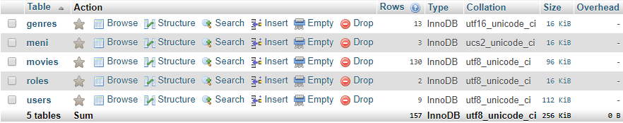

## 4.2 genres

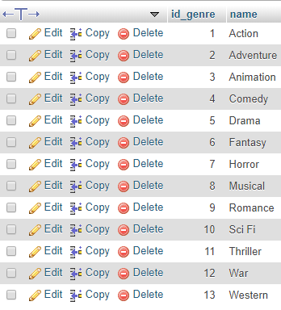

## 4.3 meni

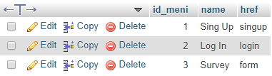

## 4.4 movies(ima mnogo vise filmova od ovoga)

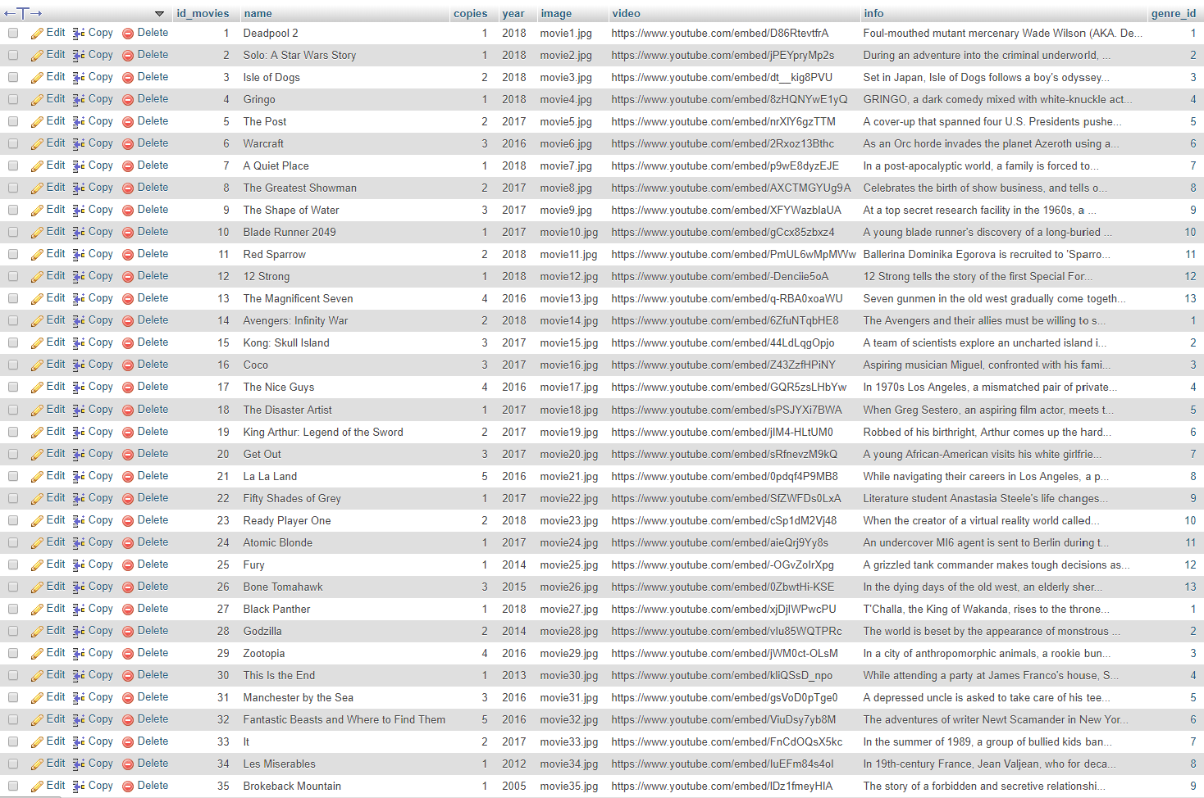

## 4.5 roles

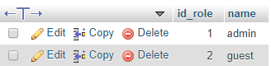

## 4.6 users

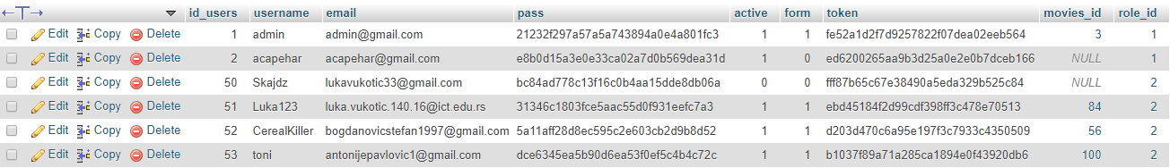

## 4.7 Desingner View

